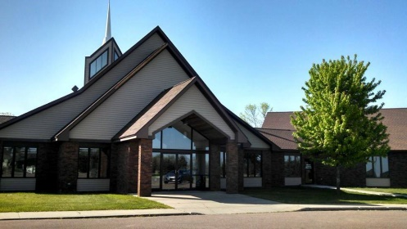
Wedding Policies
Shalom Lutheran Church
1000 E Maple St, PO Box 37
Harrisburg, South Dakota 57032
phone 605-767-5382 office@shalomlc.com

Thank you for your interest in having your wedding at Shalom Lutheran Church, Harrisburg, South Dakota. As you read through this booklet, our hope is that many of your questions will be answered. Certainly, not every possible issue is covered, but we have made an effort to address the most common questions. Please feel free to contact the church office at 605-767-5382 or by email at office@Shalomlc.com. (revised October 2016)

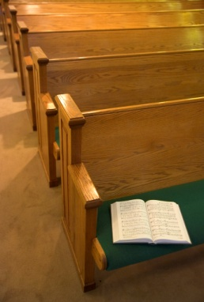
Who May Have a Wedding at Shalom?
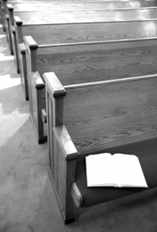
Although we want to welcome all people to our church, many request use of a church for a wedding simply based on “appearance”; they like the look of the place and think it would make a good setting or “backdrop” for their photos. In our Lutheran understanding, a marriage is a “Rite” of the Church of Jesus Christ, as those entering into the holy estate of matrimony come to their church home to ask God’s blessing upon their relationship. Those who disconnected from faith practices are encouraged to have their marriage performed by a judge, through the civil marriage system. We encourage people to consider, “If one is not involved with Jesus’ believers and His church in an intentional, committed way, why would one want to have God’s blessing on their marriage?” Certainly, getting married within the Church may be an intentional beginning to a commitment to practicing a faith life. We encourage and lift up having a faith conversation with Shalom’s pastor. Each wedding request is reviewed by pastor and sometimes by the church council as well.
How Early Should We Begin the Process?
Those who desire to be married at Shalom should contact the church office as soon as possible to inquire regarding date, availability of the pastor, musicians, and building. You will also receive important information about pre-marital counseling (discussed below), cost, etc.

Please note that weddings will not normally be scheduled on the following days:
- New Year's Eve and New Year's Day
- Holy Week (Palm Sunday through Easter)
- Memorial Day & weekend
- Synod Assembly Weekend
- Independence Day (July 4th)
- Thanksgiving Eve or Thanksgiving Day
- Christmas Eve or Christmas Day

As soon as you know of your intentions, please contact the church office to secure the date you want for your wedding. Advance notice is the best way to ensure your event.
Sanctuary Seating
The sanctuary seats 278 people. Folding chairs can be brought to gathering space to increase seating capacity, but it is the responsibility of the family/couple to return the chairs after the wedding ceremony. The sanctuary is air-conditioned during the summer months. Shalom will make earnest attempts to make the worship comfortable.

What is Pre-marital Counseling?
Marriage is a serious commitment, and one that brings with it unusual strains, pressures, and difficulties, along with joy, blessings and fulfillment. Because Jesus’ church views the marriage bond as a life-long commitment, we encourage those considering marriage to look honestly at themselves, their relationship, and strengths, as well as their areas for growth. At Shalom, as in most Christian congregations, we require that this happen through “pre-marital counseling”. The couple should contact the pastor/counselor as early as possible, arrange a starting time for meeting, and begin the process no later than 3 months prior to the wedding. It is recommended that you, as a couple, arrange for pre-marital counseling sessions through the professional services of Stacy Gorman. Her fee is approximately $225 for 3 sessions, and she can be contacted at 605-940-6422 (fees subject to change). If you would prefer to have premarital counseling completed elsewhere, a release of information must be shared with the pastor.
Consider this the most valuable money spent in preparation for your wedding. Perhaps parents or family might consider covering the cost of “premarital counseling” as their gift to the couple.

How Do We Plan the Marriage Service?
Although the bride and groom are the ones making their marriage commitment, above everything else, the marriage service is a service of worship in which the wedding party and invited guests are worshipers. The worship is a glad service overflowing with joy, and those who participate in this service focus on God, Christ’s presence, and the many gifts of the Holy Spirit. For this reason, the marriage service will normally follow the form found in this booklet. However, if you choose to get married during a regular, Sunday morning worship service, there will be no fees and service will be modified to serve the whole congregation. This service utilizes the richness of the Lutheran tradition within the one, holy, catholic (meaning “unified”) and apostolic Church. It encourages participation of all who are present, ensures the integrity of the service, and provides the needed structure. The worship is designed to present a variety of options, suggestions and possibilities. Bear in mind, however, as Christian marriage is a “rite” of the church, it is important to discuss with the pastor regarding the service, music, decorations, worship furnishings and articles.

May the Marriage Service Include Holy Communion?
When those being married are members of this congregation (bride and/or groom), or are active Christians in another congregation, the wedding may include the service of Holy Communion. The bride and groom, family members or friends may be used as communion assistants, heightening the special nature of the Lord’s Supper as a gift for all present. When Holy Communion is celebrated as part of a wedding worship, the meal is always open to the whole congregation (regardless of denomination), and never restricted to only the bride and groom or wedding party.

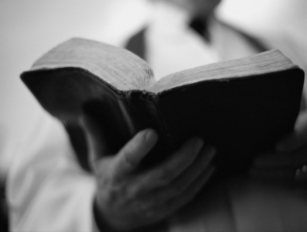
Selecting the Scripture Lessons and Vows for the Marriage Service:
Scripture: The bride and groom, working in consultation with the pastor, are encouraged to select the passages from Scripture that they would like read at the wedding. A list of some appropriate passages is located in the booklet. One, two, or three Scripture lessons may be read.

Vows: Also included in this booklet are several vows from which the couple may choose. The vows are the words that the bride and groom will speak to make their commitment to each other, before God and the witnesses gathered. Choose the vows that best reflect your thoughts and feelings about your relationship. If you would like to combine certain parts of one vow with another, the pastor will assist you. You may also choose to write your own vows; be sure to speak with the pastor about this process. Your words ought to reflect the blessings of God, mutuality of your relationship, commitment to faith, and life-long intentions.

A: I take you, name, to be my (wife/husband), and these things I promise you: I will be faithful to you and honest with you; I will respect, trust, help and care for you; I will share my life with you; I will forgive you as we have been forgiven; and I will try with you better to understand ourselves, the world, and God; through the best and worst of what is to come until death parts us.

B: I take you, name, to be my (wife/husband). I promise before God and these witnesses to be your faithful (husband/wife), to share with you in plenty and in want, in joy and in sorrow, in sickness and in health; to forgive and strengthen you, and to join with you so that together we may serve God and others as long as we both shall live.

C: Name, I take you to be my (wife/husband) from this time onward; to join with you and to share all that is to come, to give and to receive, to speak and to listen, to inspire and to respond, and in all circumstances of our life together to be loyal to you with my whole life and with all my being until death parts us.

D: I take you, name, to be my (wife/husband) from this day forward; to join with you and to share all that is to come, and I promise to be faithful to you until death parts us.

E: (traditional) I, name, take you, name, to be my (wife/husband) from this day forward; to join with you and share all that is to come, and I promise to be faithful to you until death parts us.

How Do We Select A Musician and Music?
Most weddings include music in some form, whether organ or piano, vocal soloist, guitar or flute, or congregational hymn. Almost any instrument may be used within the marriage service.

You may contact one of Shalom’s organists/pianist: Linda Slack (743-2354), Sandra DeGeest (201-2434), Michele Hawk (595-2257). Consult with the organist at least three months prior to the wedding. In the event that the organist has a scheduling conflict with your wedding date, you may provide a substitute organist. If you have a friend or relative who would like to play, you may do so, making certain they are competent and comfortable playing for a wedding and present for rehearsal.

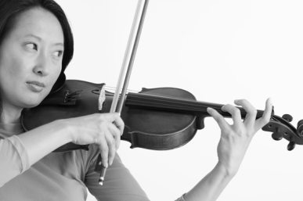
Contact professional musicians as early as possible to see if they are available, and what they charge. You are responsible for payment, and should bring a check made out to the musician(s) for the proper amount, to the rehearsal. The wedding coordinator will hold the check for the musician(s) until after the wedding. This assures the musician(s) are paid in a timely fashion and are not “forgotten” in the excitement after worship.
Keep in mind the marriage service is a service of worship, and if there is special music, it must be carefully chosen. It should embody high standards of quality and the texts should reflect the praise of God, the steadfast love of Christ for His Church as the foundation and model for love and fidelity in marriage, the invocation of God’s presence and blessings. Consequently, much secular music is not appropriate. Again, the pastor should be consulted early about choice of music, and is the final approval authority.

May We Have Our Service Without “Special” Music? Music is not required for weddings. Many simple services without music are beautiful, dignified and memorable.

Is There a Rehearsal for the Wedding? The rehearsal is normally scheduled for the evening prior to the service, and will be coordinated by the pastor and/or the wedding coordinator. All musicians, attendants, parents (perhaps grandparents) and the bridal couple should be present, punctual, and sober. The rehearsal will last no more than an hour.

May We Have Other Clergy Officiate Our Wedding at Shalom? Other Christian clergy may officiate your wedding at Shalom, with prior approval and discussion of the pastor of Shalom. These clergy need not be Lutheran; however they must feel comfortable within the Lutheran church. They may not “rearrange” the church or chancel; the pulpit, baptismal font, etc., must remain in place. There must be respect for this congregation’s worship space, worship practices and policies. Other clergy should contact the pastor of Shalom as early as possible to discuss officiating a wedding at Shalom.

What Decorations May Be Used?
- Flowers or plants are allowed, but must not be placed on the altar or in front of the altar or pulpit in such as way as to block or obscure the centrality of the altar and pulpit. Flowers or plants may be placed on the plant stands in the front of the church. Arrangements cannot be placed on piano or organ. The wedding coordinator will determine if the placement of flowers/plants is acceptable.
- Bows or decoration may be affixed to pews at the aisles, within reason.
- The paraments (the colored altar coverings and banners) are always the liturgical color of the church season and cannot be changed to coordinate your color scheme.
- Aisle runners are not permitted at Shalom.
- Candelabras are available for use; $30 fee for beeswax candles (see fee schedule).
- Flower petals may be scattered during the procession, but they must be artificial. We ask also that they are picked up following the service.

May We Use A Unity Candle?
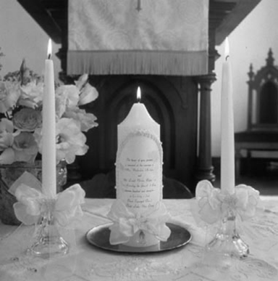
Although a “Unity Candle” is not a required part of the wedding service, it may be included in the Rite of Marriage. Shalom has a candle stand (which may be placed on a table) which you may utilize for the worship. Please take care in purchasing non-drip taper candles. You may also choose to purchase your own candle stand if you wish to take it with you. Be sure to bring the items to the church for the rehearsal. The unity candle-lighting usually takes place after the exchange of vows and rings. Music may be played/sung during the lighting of the candle, however it is not required. The couple will sign the marriage certificate immediately after the lighting of the candle. Unity Sand/tying of knots/other alternatives may also be used, with permission of pastor.

What is the Church’s Policy Regarding Photography/Videography?
Photographs and videos may be taken as desired before the service begins and after the service has ended, including the procession and recession. During the worship service, photographs may be taken from the rear of the church, with no flash. Video cameras may be used from the rear of the church during the service, provided aisles are left clear and unobstructed. Altar pictures may be taken before or after the service.

May We Throw Rice or Bird Seed?
No rice, bird seed, or flower petals may be thrown as the couple leaves the church. If you wish to release balloons, please ensure they are biodegradable. Many couples choose to use the small vials of “bubbles” that may be blown while the couple emerges from the church.

What is the Church’s Policy Regarding Smoking, Alcohol, etc.?
No smoking/alcohol is allowed anywhere in the building or on the Shalom property at any time. Please inform guests/participants in this regard. No alcohol or illegal substances are allowed in the building or on the grounds (including vehicles). We will not hesitate to cancel the wedding if this policy is violated, or if any of the wedding party is remotely impaired by the use of such substances; please respect Shalom’s policy in this regard.

Ushers
It is recommended that a minimum of one usher per 75 guests be present to seat guests and family members. More ushers will be needed if you intend to invite more than 150 guests. Groomsmen may serve as ushers.

Getting Ready
You may use the Sunday School/Fellowship Hall/Fireside Room for changing and for refreshments prior to the wedding. It is the responsibility of the wedding party to remove all personal items immediately following the ceremony. It is recommended that you assign someone to gather up all the wedding decorations and other miscellaneous items after the wedding in the sanctuary, hallways, and fellowship hall. This includes food and beverage containers. Shalom Lutheran Church is not responsible for lost or stolen items. We will hold any items found in the church office until retrieved.

What about the Marriage License?
South Dakota law requires couples to secure a license to marry. You may apply for a license at the Register of Deeds Office in your county of residence. You may apply for the license up to twenty days before the wedding (there is no waiting period). The bride and groom must be present to apply (with picture identification, social security numbers).

Bring the marriage license with you to the rehearsal. The pastor will keep it until the wedding, and will organize the signing. After the wedding, the church office will return the completed license to the appropriate county office immediately. You will receive the decorative certificate following the wedding service. Contact the Registrar of Deeds to obtain a legal copy of the marriage license a few weeks after the wedding.

May we have a Printed Bulletin for our Wedding?
A simple order of worship is often helpful, but not necessary for your wedding. If you choose to order or make wedding bulletin folders please consult with the pastor to ensure your order of service matches.
Prelude Music
Processional Music
Word of Welcome
Invocation
Prayer
*Musical Selection (optional)
Scripture
Meditation
Preparation for the Vows
The Vows
The Exchange of Rings
The Announcement of the Marriage
Unity Candle & Signing of the Marriage Documents
*Musical Selection (optional)
*Holy Communion (optional)
The Blessing
Prayers
The Benediction
The Presentation
The Recessional
Postlude Music

Some Suggested Scripture Lessons for Weddings

You may use other scripture verses as well.

You are encouraged to select scripture that will be consistent with themes you want to emphasize in this worship. One or more readings is appropriate. You may wish to choose a psalm to be sung, either by a soloist or the congregation. Members of your family or wedding party may serve as readers of the scripture you select. If you would like assistance choosing a passage, please let the pastor know. Below are some suggestions to help get you started:

Old Testament:

Genesis 1:26-31

Genesis 2:18-24

Genesis 24:50-53, 58-67

Joshua 24:15

Ruth 1:16-17

II Samuel 7:29

Psalm 33:1-9

Psalm 33:18-22

Psalm 37:3-5

Psalm 95:1-7

Psalm 98

Psalm 100

Psalm 115:9-18

Psalm 117

Psalm 119:105

Psalm 127

Psalm 128

Psalm 145

Psalm 147

Proverbs 3:5-6

Proverbs 24:3-4

Ecclesiastes 3:1-8

Song of Solomon 2:10-13

Song of Solomon 8:6a, 7

Jeremiah 33:11

Pauline Epistle:

Romans 15:5-6

Romans 8:31-35, 37-39

Romans 12:9-12

Romans 14:1-3

Romans 15:5-6

I Corinthians 13

Ephesians 3:14-19

Ephesians 5:21-23

Philippians 2:1-11

Philippians 4:4-8

Colossians 3:12-17

I Peter 2:4-9

I John 4:7-16

Gospel:

Matthew 5:13-16

Matthew 6:25-34

Matthew 7:24-27

Matthew 19:4-6

Matthew 22:35-40

Mark 10:6-9

John 2:1-11

John 13:34

John 15:9-17

